ApexPlanet Internship – Task 1
Foundation & Environment Setup

Name: BHUKYA MEENAKSHI
Task: Task-1
Submission Date: 4-6-2026

Objective
Briefly explain the goal of the task.
Tools Used
- Oracle VirtualBox
- Kali Linux
- Metasploitable2
- Wireshark
- Nmap
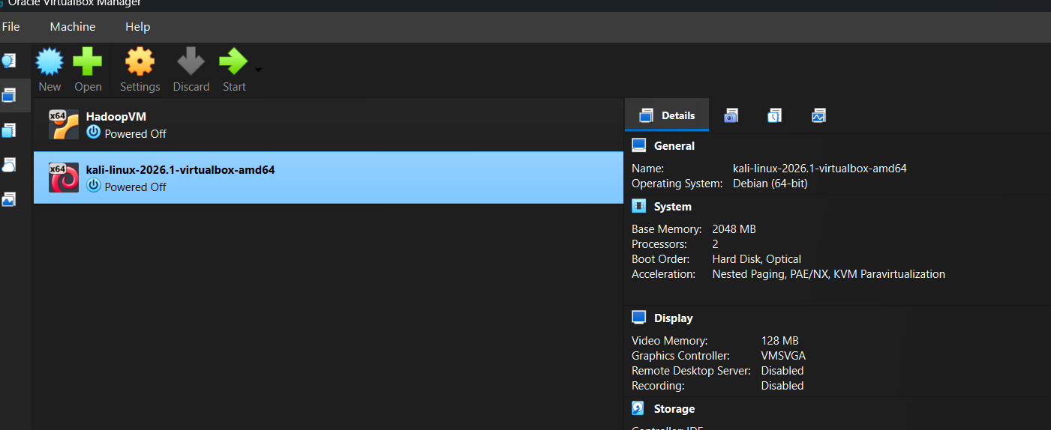
1) Oracle VirtualBox and Kali Linux

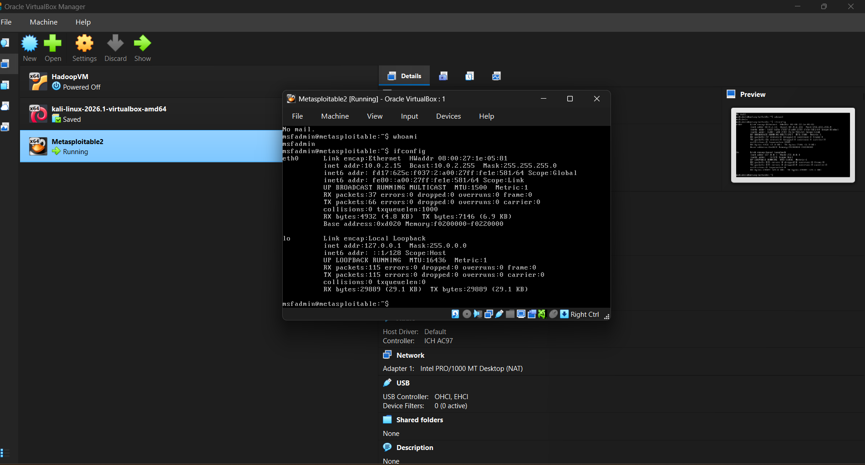
2) Metasploitable2

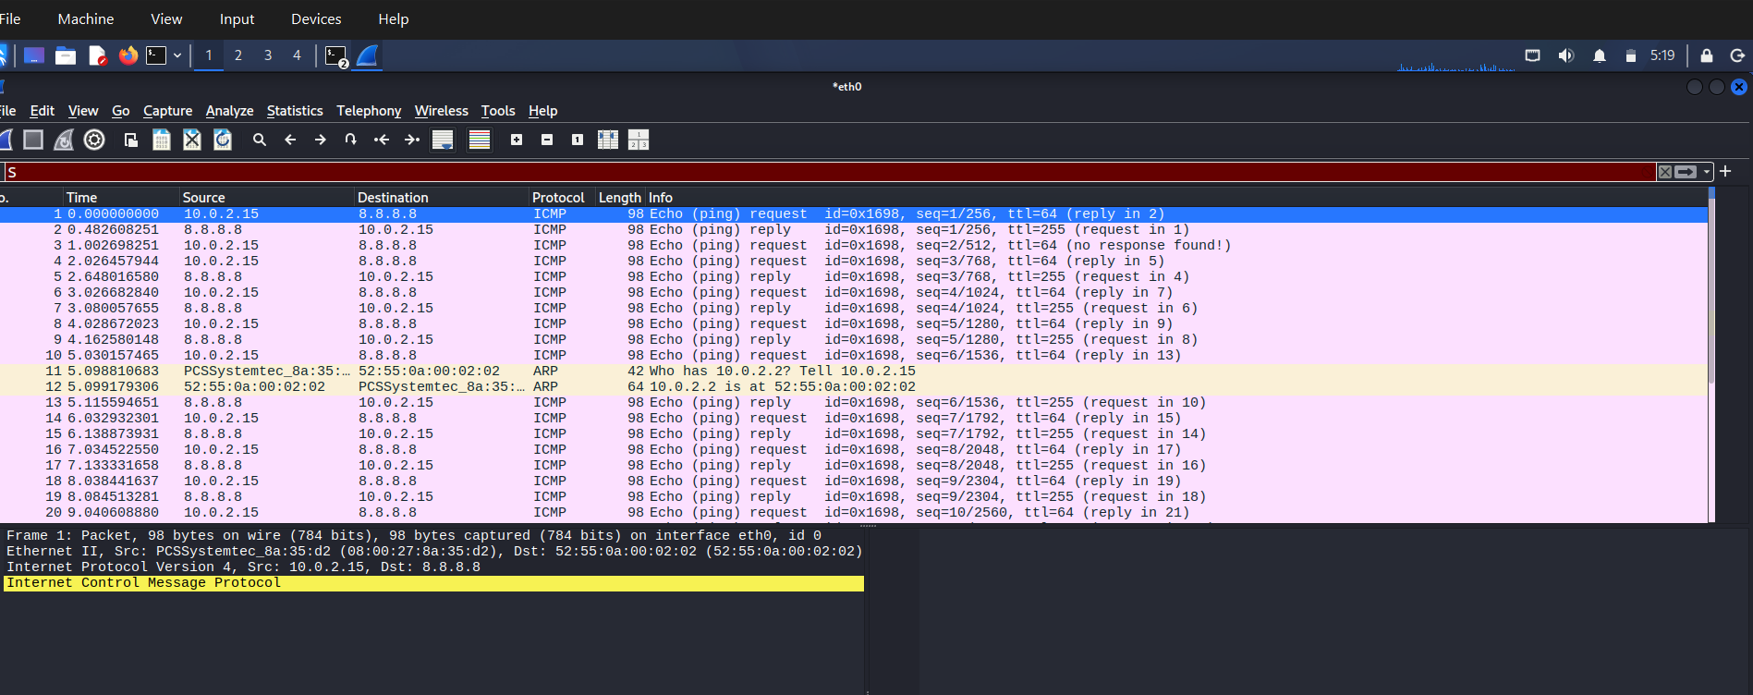
3) Wireshark

4) ) Nmap Scan
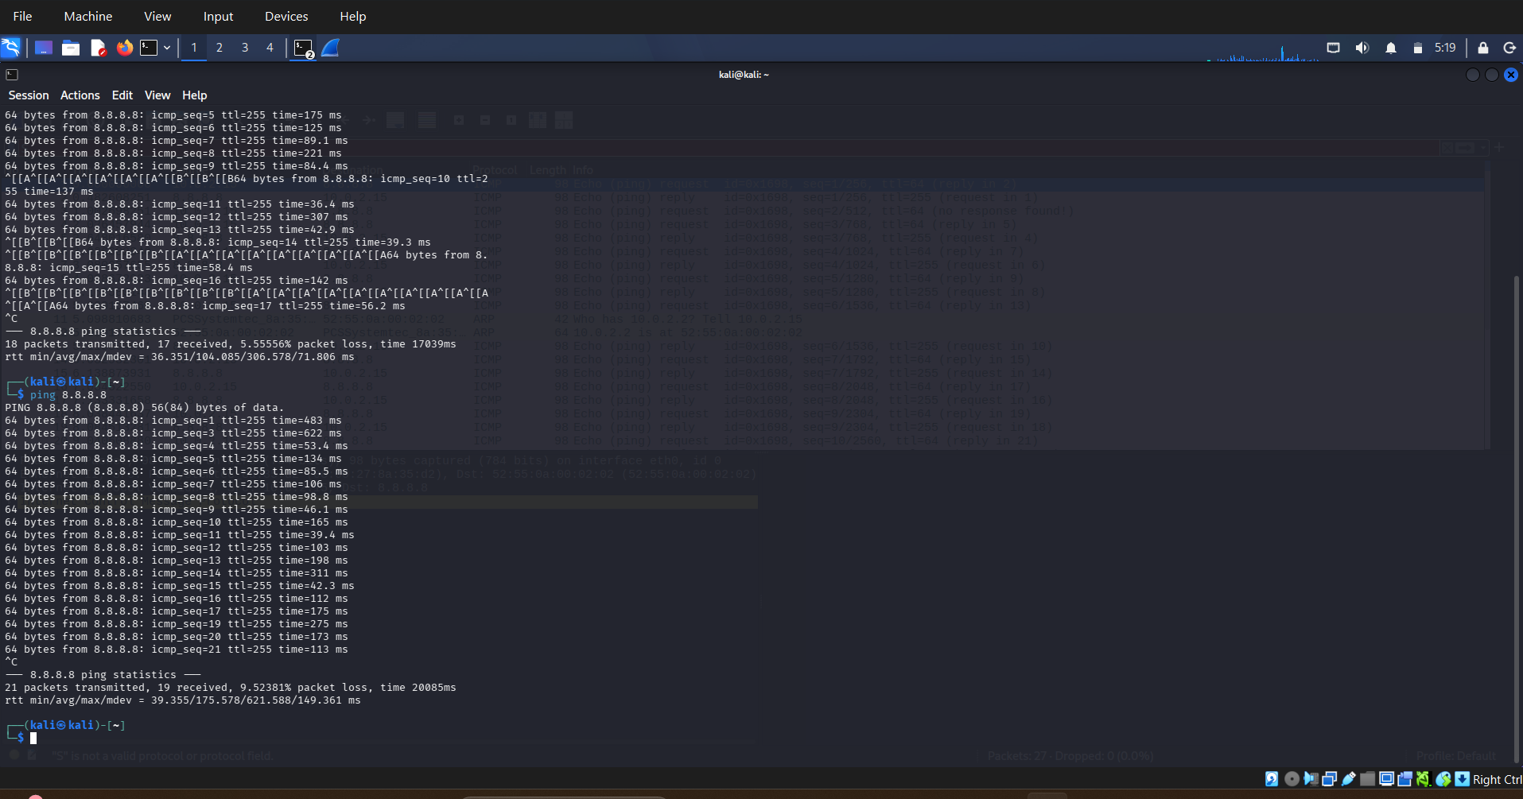

Conclusion
In this task, I successfully set up a cybersecurity lab environment using Oracle VirtualBox, Kali Linux, and Metasploitable2. I learned the fundamentals of cybersecurity, including the CIA Triad, common cyber threats, networking concepts, and basic cryptography. I also gained hands-on experience with Linux commands, network scanning using Nmap, and packet analysis using Wireshark. This task helped me understand the practical aspects of cybersecurity and provided a strong foundation for future security testing and analysis.

